Name: | David Daniels
UID: | 2023300038
Experiment No. | 3

AIM: | Constructor
Program 1
PROBLEM STATEMENT : | The "User" class represents a user on a ‘buy and stream’ movie platform with attributes : name, age, account balance. The “Movie” class represents a movie on the platform with attributes: Movie Title, AgeRestriction, Cost of the movie. The User class should have a method to check whether he can watch a movie based on his age and also account balance. The User class should also have a method to WatchMovie where he has to pay the cost for the Movie to watch it. The Movie class should have methods to get Cost and Age restriction. The main method should create objects of the "User" and "Movie" classes and demonstrate the use of their methods. Input should be taken from the user.
PROGRAM: | import java.util.*;  class user  {  Scanner sc = new Scanner(System.in);  private String name;  private int age;  private int bal;  movie_data m1 = new movie_data("Sholay", 16, 200,1);  movie_data m2 = new movie_data("Que", 18, 800,2);  movie_data m3 = new movie_data("Red Sun", 12, 1200,3);  user (String s , int a , int b)  {  this.name =s;  this.age = a;  this.bal=b;  }  int choice=0;  void show_opt()  {  System.out.println("Here is list of available movies ");  System.out.println("which movie do you want to buy?");  m1.print_mov();  m2.print_mov();  m3.print_mov();  System.out.println("Enter movie id: ");  choice = sc.nextInt();  sc.close();  buy_mov(choice);  }  void buy_mov(int c)  {  if(choice==1)  {  if(age>=m1.age_res && bal>=m1.cost)  {  bal-=m1.cost;  System.out.println("you have now bought "+m1.mov_name);  System.out.println("now playing "+m1.mov_name);  }  else  {  System.out.println("You have no money or you are not old enough");  }  }  else if(choice==2)  {  if(age>=m2.age_res && bal>=m2.cost)  {  bal-=m2.cost;  System.out.println("you have now bought "+m2.mov_name);  System.out.println("now playing "+m2.mov_name);  }  else  {  System.out.println("You have no money or you are not old enough");  }  }  else  {  if(age>=m3.age_res && bal>=m3.cost)  {  bal-=m3.cost;  System.out.println("you have now bought "+m3.mov_name);  System.out.println("now playing "+m3.mov_name);  }  else  {  System.out.println("You have no money or you are not old enough");  }  }  System.out.println("You now have: "+bal);  }  }  class movie_data  {  String mov_name;  int age_res;  int cost;  int mov_id;  movie_data(String m , int r , int c , int i)  {  this.mov_name=m;  this.age_res=r;  this.cost=c;  this.mov_id=i;  }  void print_mov()  {  System.out.println("Movie name: " + mov_name);  System.out.println("Movie id: "+mov_id);  System.out.println("age restriction: "+age_res +"+");  System.out.println("Movie cost: "+cost);  System.out.println("\n");  }  }  public class movie {  public static void main(String[] args) {  Scanner sc1 = new Scanner(System.in);  System.out.println("Enter your name: ");  String name =sc1.next();  System.out.println("Enter your age: ");  int age=sc1.nextInt();  System.out.println("enter your pocket money: ");  int bal=sc1.nextInt();  user u1 = new user(name , age , bal);  u1.show_opt();  sc1.close();  }  }
RESULT: 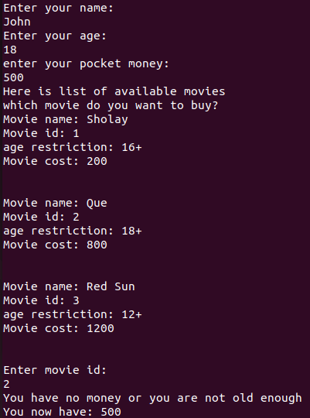

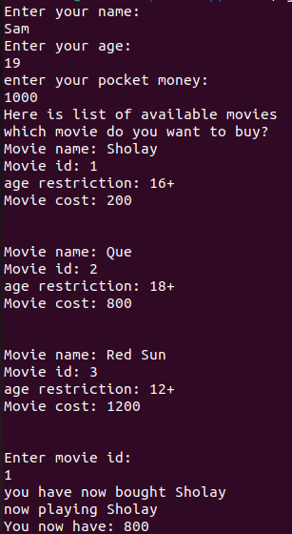
Program 2
PROBLEM STATEMENT : | The "User" class represents a social media user with attributes: username, password. The class should have a method to get username.  The "Post" class represents a social media post with attributes such as postID, LikesCount, and CommentsCount.  It should have methods to display no. of likes and comments for a post.  The User class also has methods to like/comment on posts.  The main method should create objects of the "User" and "Post" classes and demonstrate the use of their methods  Also imlement password checks.
PROGRAM: | import java.util.*;  class user  {  private String username;  private String password;  user(String u , String p)  {  this.username=u;  //boolean val_pas;  char a=p.charAt(0);  int plen=p.length();  if(plen>8 && plen<32 && !(p.contains("\\") || p.contains("/") || p.contains("=") || p.contains("\'") || p.contains("\"") || p.contains(" ")) &&(Character.isUpperCase(a) || Character.isLowerCase(a)))  {  this.password=p;  System.out.println("Password is correct ");  }  else  {  System.out.println("Password is wrong , try again");  //End program  System. exit(0);  }  }  post p1 = new post(3, 2, 1);  void update (int c) {  if (c==1)  {  p1.like++;  }  else if(c==2)  {  p1.comment++;  }  else  {  p1.comment++;  p1.like++;  }  System.out.println("New data: ");  p1.print_data();  }  void print_ini_dat()  {  System.out.println("initial data: ");  p1.print_data();  }  }  class post  {  int like;  int comment;  int post_id;  post(int l , int c , int p)  {  this.like=l;  this.comment=c;  this.post_id=p;  }  void print_data()  {  System.out.println("Likes: "+like);  System.out.println("Comments: "+comment);  System.out.println("Post Id:"+post_id);  }  }  public class media  {  public static void main(String[] args)  {  Scanner sc = new Scanner(System.in);  System.out.println("Enter username: ");  String user = sc.next();  System.out.println("Enter password: ");  String pass =sc.next();  user u1 = new user(user,pass);  u1.print_ini_dat();  System.out.println("do you want to like, comment or do both to the post");  System.out.println("press 1 to like , 2 to comment , 3 to like and comment");  int c=sc.nextInt();  u1.update(c);  sc.close();  }  }
RESULT: 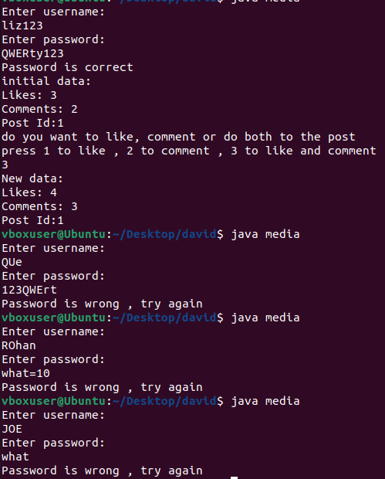
CONCLUSION: | Thus we have learned how to use constructors in Java.

